Using Client Certificate Authentication with IIS 6.0 Web Sites
What methods do you use to control access to your secure Web sites? Do you require authentication? If so, what type of authentication? Are the users’ credentials passed in clear text? Do you secure data moving between the Web site and the client, or can anyone with a network sniffer read all the data moving between the Web client and the Web server?
The definition of secure is a moving target. If you talk to the security wonks, they’ll tell your configuration is not secure, and that you’ll have to spend untold number of dollars and administrator hours to correct the security flaws in your network. Meanwhile, if you were to go to the security consultant’s home, you’ll find he has glass windows and clear glass panes on his doors which are easily breakable. Any run-in-the-mill burglar can make off with his stereo and laptop computer sitting on the desk inside.
When we put together a secure Web site (for employee access, not for e-commerce as e-commerce sites have an entire different set of requirements), we require two factor authentication. Two factor authentication requires two methods be used when accessing content on the secure Web site. For example, one factor can be the username and password, and the second factor can be biometric input, such as a fingerprint. The two factor authentication methods typically depend on what I know and what I have.
Most two-factor authentication schemes require very pricey third party devices that provide the what I have component. The most popular two-factor authentication method is RSA SecurID. The SecurID token generates a one time password users use when they authenticate with a secure Web site. SecurID is a very powerful two-factor authentication scheme and I highly recommend it for organizations that can afford it.
Even if you don’t have hoards of excess cash, you can still benefit from two factor authentication. If you have a Windows 2000 or Windows Server 2003 Server (such as the domain controller in your Active Directory domain), then you can put together your own two-factor authentication scheme. You can install a Microsoft Certificate Server on the Windows Server machine and issue user certificates to your users. Then you can configure your Web site to require both username and password and a user certificate. The user certificate is the what I have piece of the two factor authentication scheme.
In this article we’ll go over procedures required to make this two-factor authentication method work. You’ll need to do the following:
- Install IIS 6.0 on the Windows Server 2003 computer
- Create an offline certificate request file using the Web Site Certificate Wizard
- Submit the offline certificate request to the Certificate Server using the Web Enrollment Site
- Install the Web site certificate
- Install the CA certificate
- Configure the Web site to require a client certificate and use basic authentication
- Request a User Certificate from the Web enrollment site
- Make the connection to the Web site
Our sample network includes a Windows XP client machine, a Windows Server 2003 Web server and a Windows Server 2003 domain controller that has an enterprise CA installed on it. The enterprise CA must be installed on a machine that is a member of an Active Directory domain. We will use the Web enrollment site on the enterprise CA to obtain certificates. Note that you can also use a standalone CA, which does not require an Active Directory domain. The user interface on the standalone CA differs a bit from the enterprise CA’s Web enrollment site, but the same principles apply.

Install IIS 6.0 on the Windows Server 2003 Computer
We will use an IIS 6.0 Web server in our example. You can also use IIS 5.0 and the procedures are essentially the same, although the Web Site Certificate Request Wizard looks a little different, the basic functionality and procedures are the same.
The first step is to install the IIS WWW service on the Web server computer. We need to do this because unlike Windows 2000 where the WWW is installed by default, it is not installed by default on a Windows Server 2003 server.
Perform the following steps to install the IIS 6.0 WWW service on the Windows Server 2003 machine that will act as the Web server:
1. Click Start and point to Control Panel. Click the Add or Remove Programs link.
2. In the Add or Remove Programs window, click the Add/Remove Windows Components button.
3. In the Windows Components window, click the Application Server entry in the Components list and then click Details.
4. In the Application Server dialog box, put a checkmark in the Internet Information Services (IIS) checkbox. Click OK.
5. Click Next on the Windows Components page.
6. Click OK on the Insert Disk dialog box. In the Files Needed dialog box, enter the path to the i386 folder on the Windows Server 2003 CD in the Copy files from text box. Click OK.
7. Click Finish when the Wizard is completed.

Create an Offline Certificate Request File using the Web Site Certificate Wizard
Now that the Web site is installed, we can create an offline request to obtain a Web site certificate.
There are two ways you can make a request for a certificate from a Microsoft Certificate Server: via an offline request and via the Certificates MMC. The Web site machine must be a member of the same domain as the Certificate Server if you want to use the Certificates MMC. In our example, the Web server is not a member of the domain, so we must first generate an offline certificate request file and then submit this file to the Certificate Server using the Certificate Server’s Web enrollment site.
Perform the following steps on the Web server to generate the certificate request file:
1. Click Start and then point to Administrative Tools. Click the Internet Information Services (IIS) Manager link.
2. In the Internet Information Services (IIS) Manager console, expand the Web Sites node and click on the Default Web Site node. Right click on the Default Web Site node and click Properties.
3. On the Default Web Site Properties dialog box, click the Directory Security tab.
4. On the Directory Security tab, click the Server Certificate button in the Secure Communications frame.
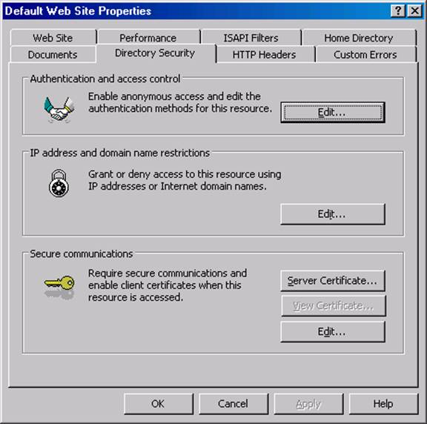
5. Click Next on the Welcome to the Web Server Certificate Wizard page.
6. On the Server Certificate page, select the Create a new certificate option and click Next.
7. On the Delayed or Immediate Request page, note that the only option available to you is the Prepare the request now, but send it later. The reason for this is that the Web server is not a member of a domain that has an enterprise CA. Accept the default option and click Next.
8. On the Name and Security Settings page, accept the default values and click Next.
9. On the Organization Information page, enter the name of your organization in the Organization text box and enter the name of your organizational unit in the Organizational Unit text box. Click Next.
10. On the Your Site’s Common Name page, enter the name of the Web site in the Common name text box. This is an extremely important entry. The name you put into this text box must be exactly the same as the name the users use to access the Web site. In this example, we will enter www.msfirewall.org into the text box. When users access this site, they will enter into their browsers http://www.msfirewall.org. Click Next.
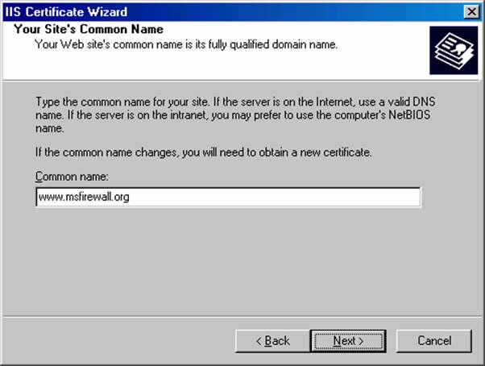
11. On the Geographical Information page, enter your State/Province and City/locality in the text boxes and click Next.
12. On the Certificate Request File Name page, accept the default location for the certreq.txt file and click Next. (Note that the file is located in the root of the C:\ drive; we’ll retrieve that file later when we make our certificate request to the Certificate Server).
13. Review the information on the Request File Summary page and click Next.
14. Click Finish on the Completing the Web Server Certificate Wizard page.
15. Click OK on the Default Web Site Properties dialog box.

Submit the Offline Certificate Request to the Certificate Server using the Web Enrollment Site
We can use the certificate request file created by the Web Site Certificate Wizard to request a Web site certificate from the enterprise CA we installed on our domain controller. To accomplish this task, we will open the Certificate Server’s Web enrollment site and send the request.
Perform the following steps to send the Web site certificate request to the enterprise CA:
1. Open Internet Explorer on the Web server machine and enter http://10.0.0.2/certsrv in the address bar, where 10.0.0.2 is the IP address of the Certificate Server. Press ENTER.
2. Enter domain administrator credentials in the authentication dialog box and click OK.
3. On the Welcome page of the Web enrollment site, click the Request a certificate link at the bottom of the page.
4. On the Request a Certificate page, click the advanced certificate request link.
5. On the Advanced Certificate Request page, click the Submit a certificate request by using a base-64-encoded CMC or PKCS #10 file, or submit a renewal request by using a base-64-encoded PKCS #7 file link.
6. On the Submit a Certificate Request or Renewal Request page, copy the contents of the certreq.txt file into the Saved Request text box. Open the certreq.txt file and then press CTRL+A to select all the text. Then press CTRL+C to copy all the text to the clipboard. Go to the Web browser windows and click in the Saved Request text box and press CTRL+V to paste the contents of the certreq.txt file into the text box. Select the Web Server template from the Certificate Template list. Click the Submit button.
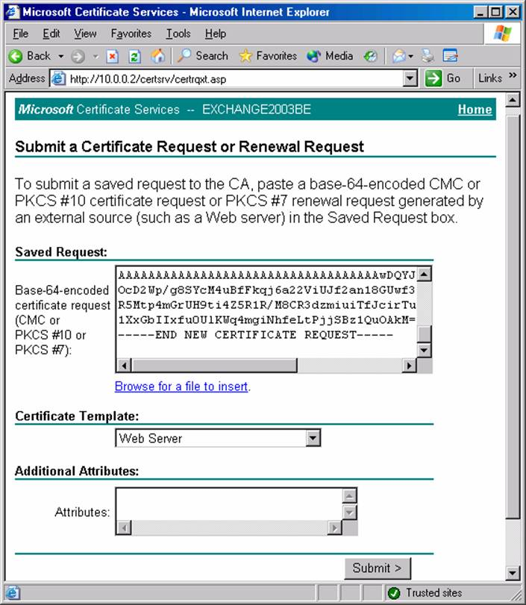
7. On the Certificate Issued page, click the Download certificate link.
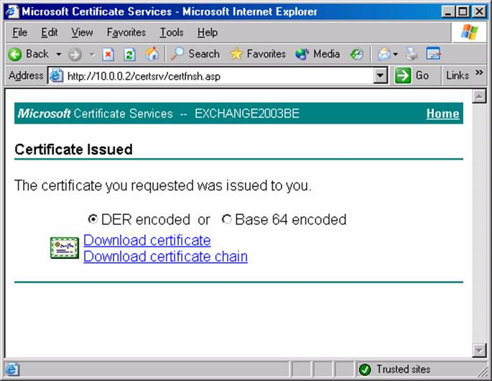
8. In the File Download dialog box, click the Save button. Save the file to the Desktop. Click the Close button.
9. On the Certificate Issued page, click the Download certificate chain link.
10. In the File Download dialog box, click the Save button. Save the file to the Desktop. Click the Close button.
11. Close Internet Explorer.

Install the Web Site Certificate
We’ve downloaded the Web site certificate and CA certificate files from the Web enrollment site. The next step is install these certificates on the Web server. We’ll begin by installing the Web site certificate and then we’ll install the CA certificate.
Perform the following steps to install the Web site certificate on the Web server:
1. At the Web server machine, click Start and point to Administrative Tools. Click the Internet Information Services (IIS) Manager link.
2. Expand the Web Sites node in the left pane of the console and then click on the Default Web Site. Right click on the Default Web Site and click Properties.
3. In the Default Web Site Properties dialog box, click the Directory Security tab.
4. On the Directory Security tab, click the Server Certificate button.
5. Click Next on the Welcome to the Web Server Certificate Wizard page.
6. On the Pending Certificate Request page, select the Process the pending request and install the certificate option and click Next.
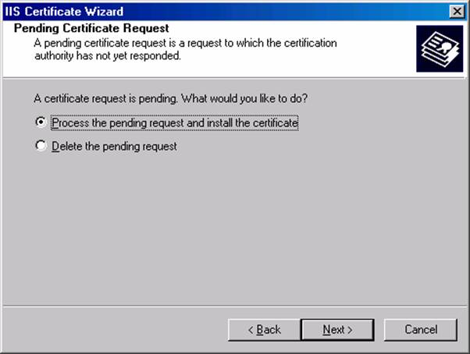
7. On the Process a Pending Request page, click the Browse button and locate the .cer file for the Web site certificate.
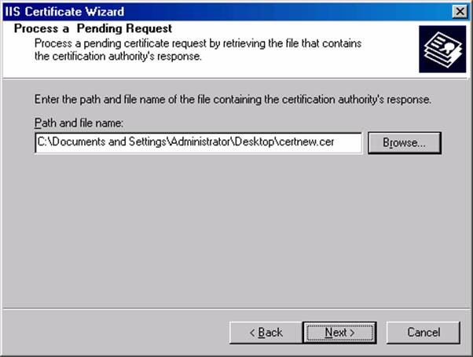
8. On the SSL Port page, accept the default SSL port, which is 443. Click Next.
9. On the Certificate Summary page, review your settings and click Next.
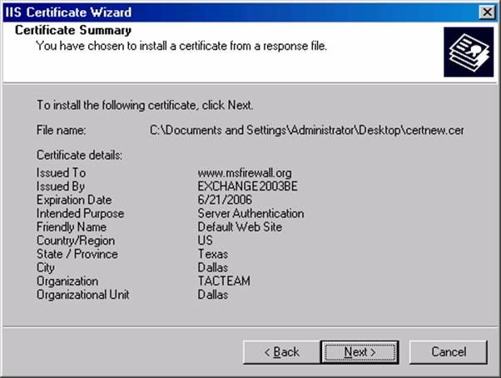
10. Click Finish on the Completing the Web Server Certificate Wizard page.
11. On the Directory Security tab, click the View Certificate button.
12. In the Certificate dialog box, click the General tab. Note that the Issued to name is www.msfirewall.org. This is the common name on the certificate. Notice that there is a red “X” on the certificate at the top of the dialog box.
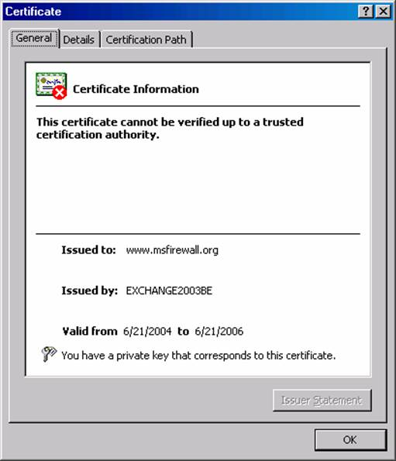
13. Click on the Certification Path tab. Notice that there is a red “X” on the root CA. This indicates that the CA certificate of the root CA is not in the Trusted Root Certification Authorities list on the Web server. We will fix this problem in the next procedure.
14. Click OK in the Certificate dialog box.
15. Click OK in the Default Web Site Properties dialog box.

Install the CA Certificate
We need to install the Root CA certificate in the Trusted Root Certification Authorities store on the Web server machine. This allows the Web server to trust the Web site certificate installed on the IIS Web site.
Perform the following steps to install the root CA certificate into the machine’s certificate store:
1. Click Start and then click the Run command.
2. In the Run dialog box, enter mmc in the Open text box and click OK.
3. In the Console1 window, click the File menu and click the Add/Remove Snap-in command.
4. In the Add/Remove Snap-in dialog box, click the Add button.
5. In the Add Standalone Snap-in dialog box, select the Certificates entry in the Available Standalone Snap-ins dialog box and click Add.
6. On the Certificates snap-in page, select the Computer account option and click Next.
7. On the Select Computer page, select the Local computer option and click Finish.
8. Click Close in the Add Standalone Snap-in dialog box.
9. Click OK in the Add/Remove Snap-in dialog box.
10. Expand the Certificates node and then expand the Trusted Root Certification Authorities node and click on the Certificates node. Right click on the Certificates node, point to All Tasks and click Import.
11. Click Next on the Welcome to the Certificate Import Wizard page.
12. On the File to Import page, click the Browse button and locate the certnew.p7b file you downloaded from the Web enrollment site. Click Next.
13. On the Certificate Store page, accept the default setting, Place all certificates in the following store and click Next.
14. Click Finish on the Completing the Certificate Import page.
15. Click OK in the Certificate Import Wizard dialog box informing you that the import was successful.

Configure the Web Site to Require a Client Certificate and use Basic Authentication
Now that our certificates are in place, we can configure the Web server’s authentication and SSL settings. Since we want a secure Web server, we’ll force users to use SSL when connecting to the site. SSL will encrypt the user credentials and data moving between the Web client and the Web server. We will also force Integrated authentication, which is more secure than basic authentication. However, the type of authentication used is not so important in this scenario, since the user credentials are protected by SSL. Finally we will configure the Web site to require a user certificate.
Perform the following steps to configure the security settings on the Web site:
1. Click Start and point to Administrative Tools. Click Internet Information Services (IIS) Manager.
2. In the Internet Information Services (IIS) Manager console, expand the server name and expand the Web Sites node. Click on Default Web Site and right click on it. Click Properties.
3. In the Default Web Site Properties dialog box, click the Directory Security tab.
4. On the Directory Security tab, click the Edit button in the Authentication and access control frame.
5. In the Authentication Methods dialog box, remove the checkmark from the Enable anonymous access checkbox. The only checkbox that should be selected is the Integrated Windows authentication checkbox. Click OK.
6. On the Directory Security tab, click the Edit button in the Secure communications frame.
7. Place a checkmark in the Require secure channel (SSL) checkbox and put a checkmark in the Require 128-bit encryption checkbox. Select the Require client certificates option in the Client certificates frame. Click OK in the Secure Communications dialog box.
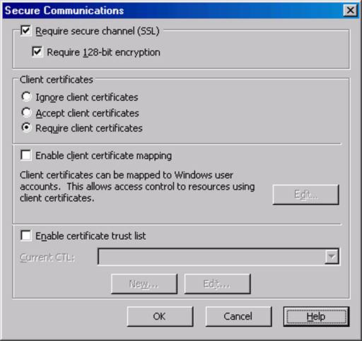
8. Click Apply and then click OK in the Default Web Site Properties dialog box.

Request a User Certificate from the Web Enrollment Site
The client computer must present a user certificate to the Web server before the Web server will accept the user’s credentials. Users can log on to the Web enrollment site and request a user certificate. The user does not need to be an administrator in the domain or on the Certificate Server computer. The user only needs to have legitimate user credentials that the enterprise CA recognizes.
Perform the following steps on the client computer to obtain the user certificate”
1. On the Web client computer, open Internet Explorer and enter http://10.0.0.2/certsrv in the address bar, where 10.0.0.2 is the IP address of the Certificate Server. Press ENTER.
2. In the log on dialog box, enter the credentials of a non-administrator user. This will demonstrate that a non-admin can obtain a user certificate. Click OK.
3. On the Welcome page of the Web enrollment site, click the Request a certificate link.
4. On the Request a Certificate page, click the User Certificate link.
5. On the User Certificate – Identifying Information page, click Submit.
6. Click Yes on the Potential Scripting Violation dialog box informing you that the Web site is requesting a certificate on your behalf.
7. On the Certificate Issued page, click the Install this certificate link.
8. Click Yes on the Potential Scripting Violation page informing you that the Web site is adding a certificate to the machine.
9. Close Internet Explorer after you see the Certificate Installed page.

Make the Connection to the Web Site
Now we’re ready to see if our settings actually work! Perform the following steps to connect to the secure Web site:
1. Open Internet Explorer and enter https://www.msfirewall.org into the Address bar, where www.msfirewall.org resolves to the IP address of the Web server.
2. A Client Authentication dialog box appears and shows a Users certificate in the list. Click the View Certificate button.
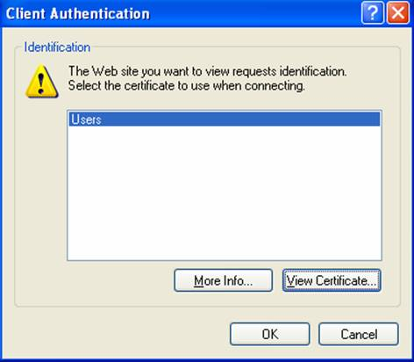
3. In the Certificate dialog box you can see the Issued to name is the name of the user who requested the certificate. Click OK.
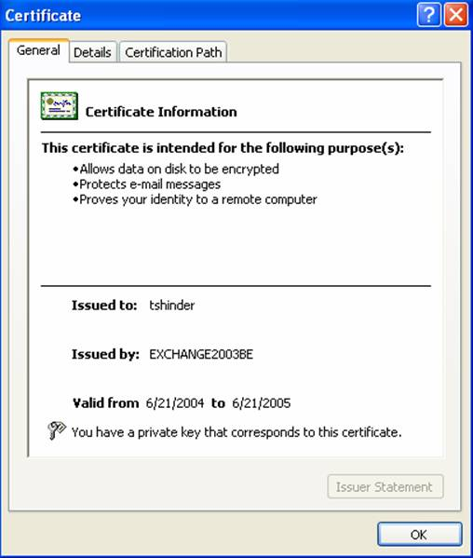
4. Click OK on the Client Authentication dialog box.
5. Enter valid user credentials in the authentication dialog box. These credentials must be valid on the Web server computer. Click OK.
6. You can see the default page on the Web site. I haven’t added anything to this Web site, so we see the Under Construction page. Notice the lock icon in the status bar indicating the we have a secure connection to the Web site.
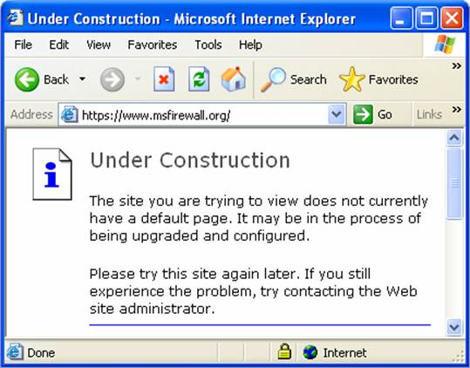
In this example we connected to the secure Web site by first providing a user certificate. Only after the user certificate was submitted were we offered the opportunity to present user credentials. It’s important to realize in this example that the user certificate is not mapped to a particular user account. The only requirement for the user certificate is that it comes from a Certificate Authority that the Web server trusts. Trust is based on the CA certificate entries in the Web server’s Trusted Root Certification Authorities machine certificate store.
You do have the option to map user certificates to user accounts. This provides an even stronger level of security, because not only must the user submit a user certificate from a trusted Certificate Authority, the user certificate must be mapped to a user account that has permission to access the Web site. If you’re interested in user certificate mapping and how to make it work with your IIS Web server, send me a note at tshinder@isaserver.org.

